# Assignment -4

Python Programming

| Assignment Date | 19 September 2022 |
| --- | --- |
| Student Name | Ajay.C |
| Student Roll Number | 963219104001 |
| Maximum Marks | 2 Marks |

# Question-1:

**Write a python program to test a given number is prime or not.**

**Solution :**

**n = int(input("Enter a number: "))**

**f = False if n> 1:**

**for i in range(2, n): if (n % i) == 0:**

**f = True break**

**if f:**

**print(n, "is not a prime number")**

**else:**

**print(n, "is a prime number")**

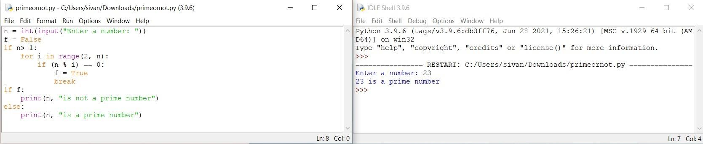

# Question-2:

**Write a program to generate odd numbers from m to n using while loop**

**Solution :**

**min = int(input(" Enter any min value:")) max = int(input(" Enter any max Value : ")) X=1;**

**if (min < max):**

**while X in range(min,max+ 1):**

**if( X % 2 != 0):**

**print("{0}".format(X)) X=X+1;**

**else:**

**print("min value you've entered is greater than max value")**

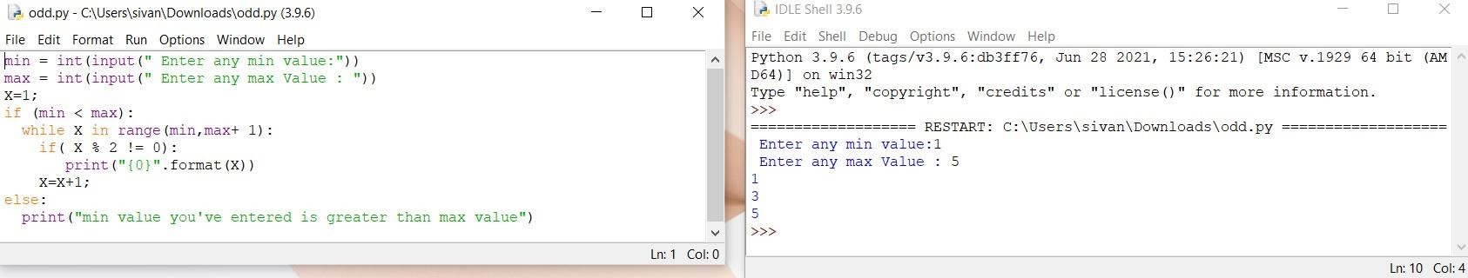

# Question-3:

**Write a Python program to display prime number series upto given number.**

**Solution :**

**l = 1**

**u = int(input("Enter the number : "))**

**print("Prime numbers between",1,"and",u,"are:") for n in range(l,u + 1):**

**if n > 1:**

**for i in range(2, n): if (n%i) == 0:**

**break else:**

**print(n)**

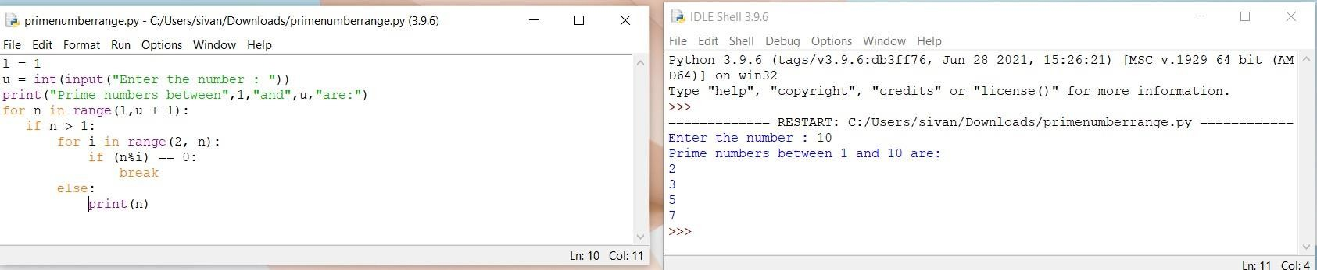

# Question-4:

**Write a Python program to generate Fibonacci series.**

**Solution :**

**nt = int(input("How many terms? ")) n1, n2 = 0, 1**

**c = 0**

**if nt <= 0:**

**print("enter a +ve integer") elif nt == 1:**

**print("Fibonacci upto",nt,":") print(n1)**

**else:**

**print("Fibonacci series:") while c < nt:**

**print(n1)**

**nth = n1 + n2 n1 = n2**

**n2 = nth c += 1**

